**Digital Service Report 0.1**

# User Manual

# Contents

User Manual 1

Contents 2

1 Login Screen 3

2 Logging into the WebUI (Superadmin) 3

2.1 Main Window (Superadmin) 3

2.1.1 All Reports List 4

2.1.2 Reports Settings 8

3 Logging into the WebUI (Manager & User) 9

3.1.1 My Reports 10

3.1.2 Template 14

3.1.3 My Activation 14

3.1.4 All Reports (Manager Only) 14

3.1.5 Requests 15

# Login Screen

The instant login page allows you to log in to the WebUI.

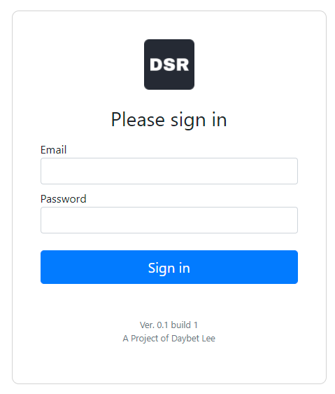

# Logging into the WebUI (Superadmin)

To log in to the WebUI, enter the default credentials for superadmin access:

* **Email** - **admin@dsr.com**
* **Password** – **P@55w0rd123**

## Main Window (Superadmin)

After you log in, the UI main window is displayed.

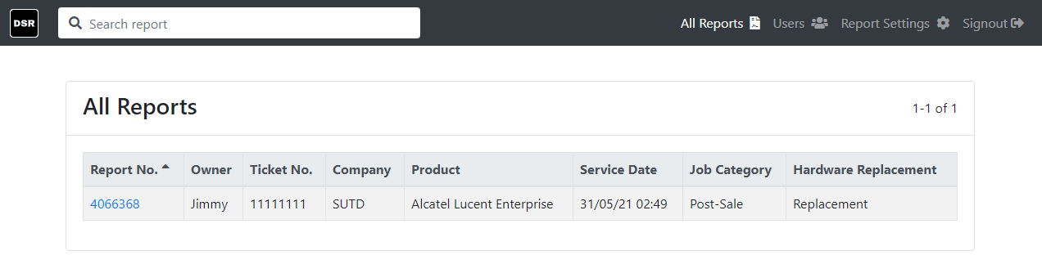

The main window consists of the following elements:

* **Search Text Box** – User can search using the r User can search for report based on the report information.
* **All** **Reports** – Page that provide a list of all reports
* **Users** – Page to manage user accounts
* **Report** **Settings** – Page to manage the report settings
* **Signout** – Log out of the application

### All Reports List

Show all historical report generated by all users. Clicking the report allowing user to view the report in details.

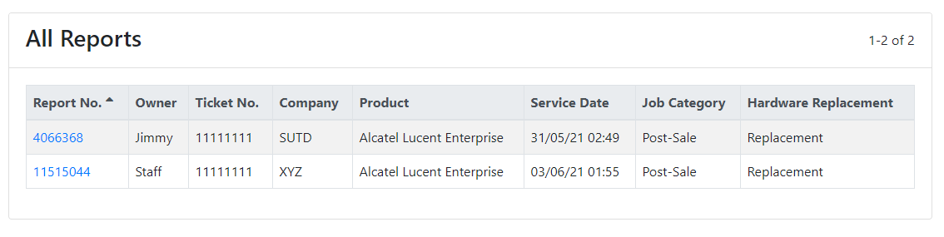

#### Users

You can manage user accounts in this page.

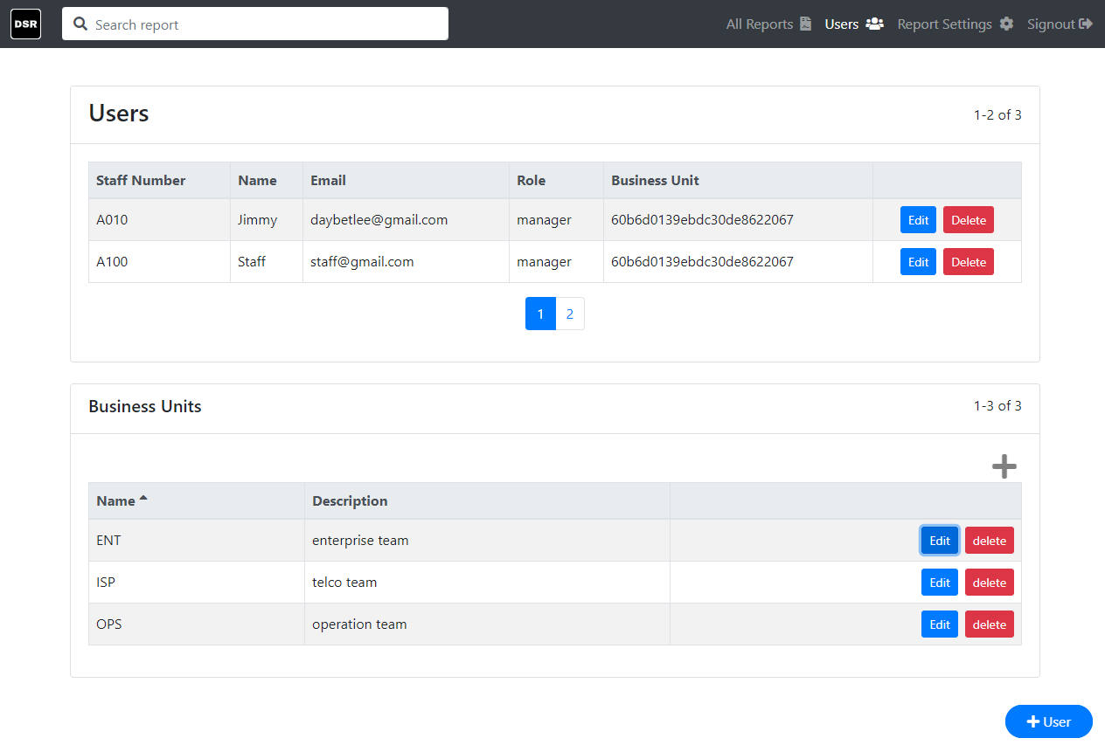

The User page consists of the following elements:

* **Users List**
* **Business Units List**
* **+ User Button**

#### Users List

This list display all created account. You can choose the following action:

* **Edit** – Change the details of a user
* **Delete** – To permanently remove a user

##### Edit

Display the user detail. You can change the detail and click **Update** to save the changes.

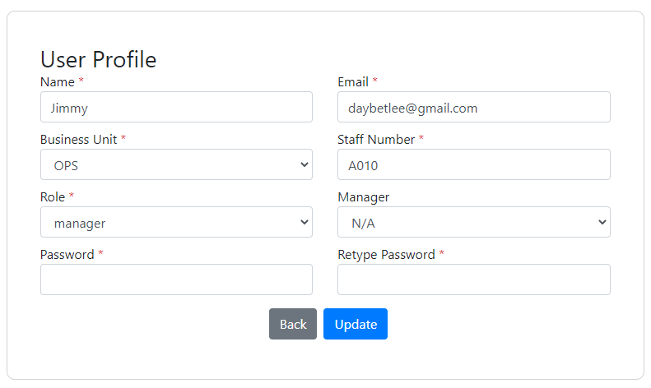

|  |  |
| --- | --- |
| **Parameter** | **Description** |
| Name | Name of the user |
| Email | Email address of the user. |
| Business Unit | Business Unit the user is from. |
| Staff Number | The employer number of the user. |
| Role | Select the user type for the user. You can select the following user type:   * Admin * Manager * User |
| Manager | Existing manager user whom is the direct superior to the user |
| Password | Password used to log in to the account |
| Retype Password | Confirm the password type is correct |

#### Business Units List

Display the business units that is used during user creation. You can choose the following action:

* **‘+’ Icon** – Add new business unit
* **Edit** – Change the details of a business unit
* **Delete** – To permanently remove a business unit

##### ‘+’ Icon

Click this icon prompt a window to add the business unit. Enter the business unit name and the description and click **Save** to add.

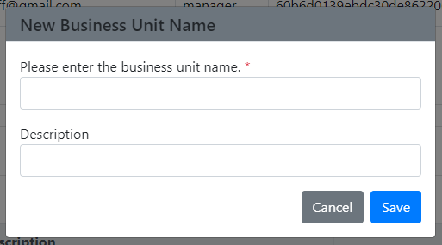

##### Edit

Display the business unit detail. You can change the detail and click **Update** to save the changes

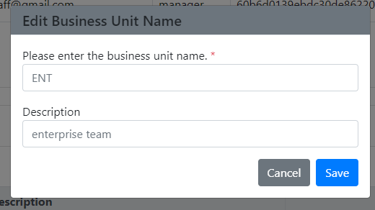

#### + User Button

Click this icon will direct a new user form. Enter the user detail **Submit** to add the user. Click **Clear** to reset the form.

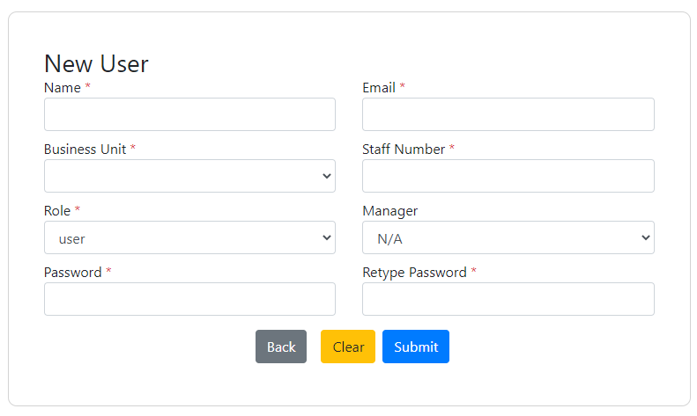

|  |  |
| --- | --- |
| **Parameter** | **Description** |
| Name | Name of the user |
| Email | Email address of the user. |
| Business Unit | Business Unit the user is from. |
| Staff Number | The employer number of the user. |
| Role | Select the user type for the user. You can select the following user type:   * Admin * Manager * User |
| Manager | Existing manager user whom is the direct superior to the user |
| Password | Password used to log in to the account |
| Retype Password | Confirm the password type is correct |

**Note:** Upon creation of user account, user will receive an email notification of an account opening based on the input email. The user however will still require to provide their signature in order to continue using the application.

### Reports Settings

You can tweak the report configurations. As of version 0.1, **Produce Vendors** is the only editable report settings.

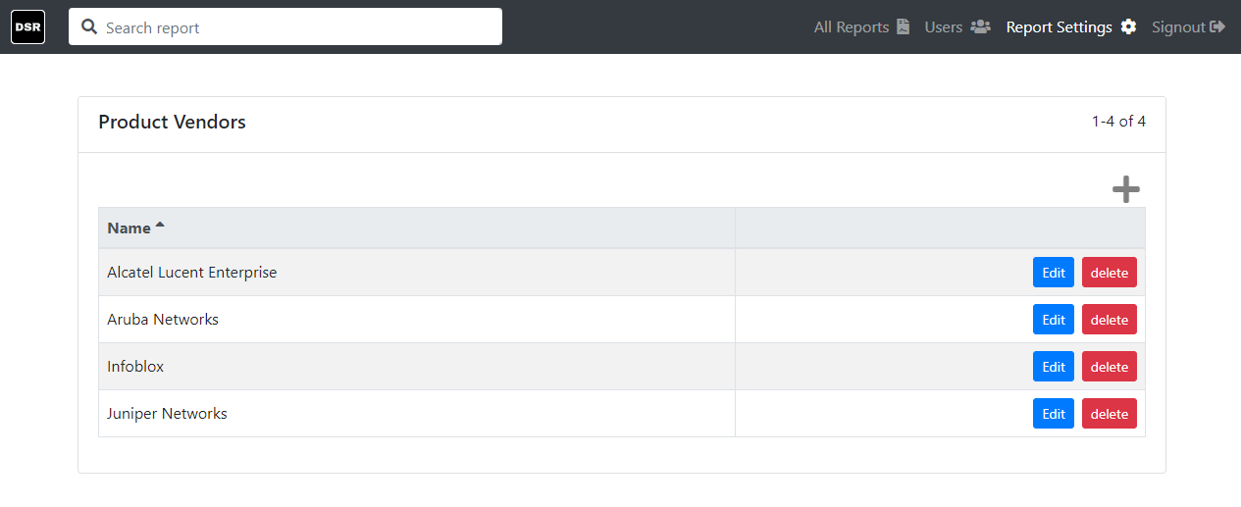

You can choose the following actions:

* **‘+’ Icon** – Add new product vendor
* **Edit** – Change the details of a product vendor
* **Delete** – To permanently remove a product from the list

#### ‘+’ Icon

Click this icon prompt a window to add a new product vendor. Enter the name and click **Save** to add.

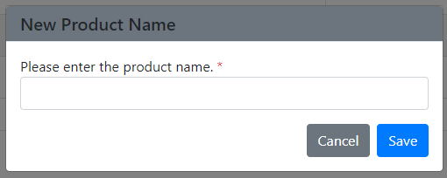

#### Edit

Display the product vendor detail. You can change the detail and click **Update** to save the changes

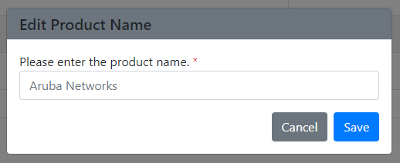

# Logging into the WebUI (Manager & User)

To log in to the WebUI, enter the credentials created by the superadmin account:

* **Email**
* **Password**

If you are login using a manager account, you will be directed to the **All Reports** page and if you are a user account, you will be directed to the **My Reports** page. User account **do not** have the access to the **All Reports** page.

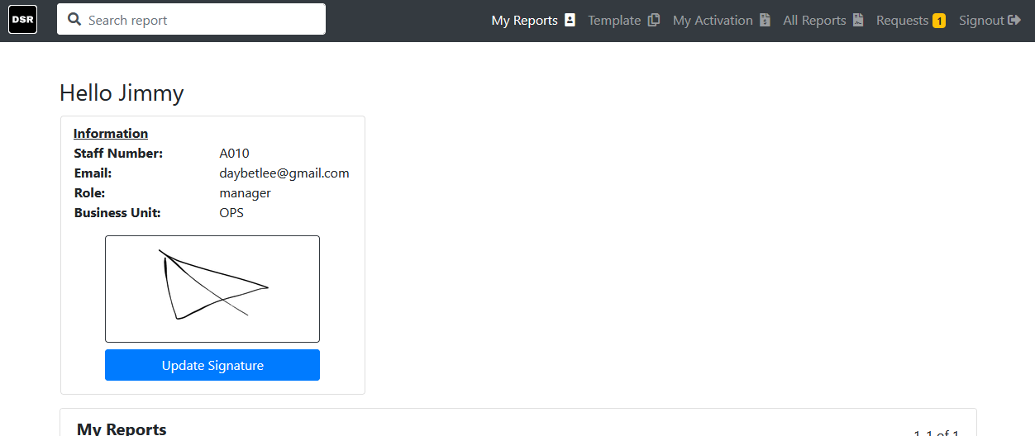

The main window for manager and user consists of the following elements:

* **Search Text Box** – User can search for report based on the report information.
* **My Reports** – User information and display their historical reports
* **Template** – Page contain the pre filled report that can be easily use to generate report
* **My Activation** – The page to generate activation claim based on the month and forward the it to finance department for processing
* **All Reports (Manager Only)** – Display all historical reports for viewing
* **Requests –** Display the signing requests for manager to acknowledge subordinate report
* **Signout** – Log out of the application

### My Reports

Contain the current user information and the **My Reports** list displaying all historical reports that the user has created.

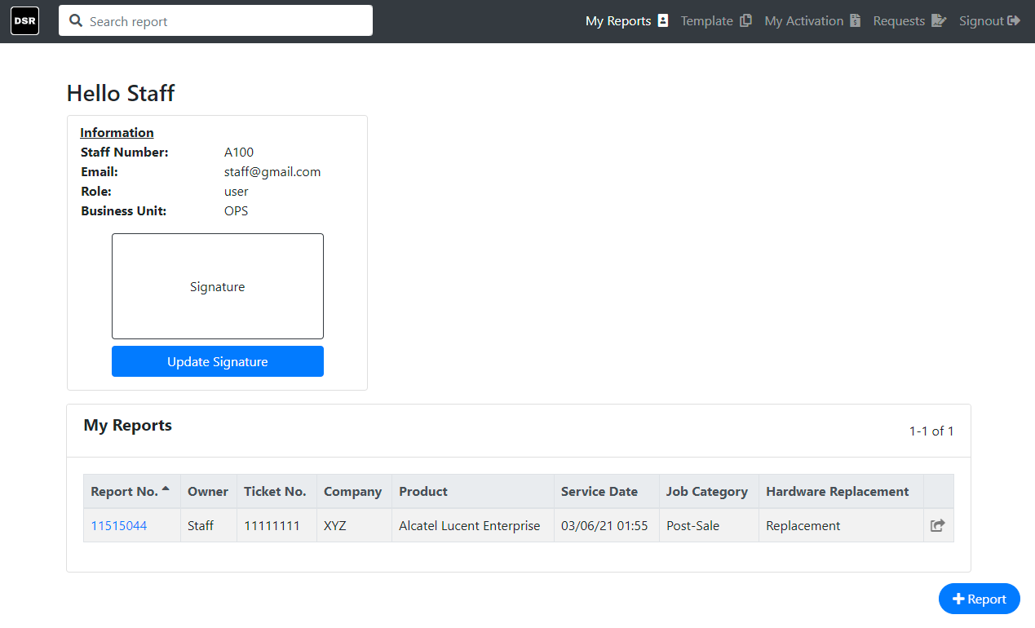

You can choose the following actions:

* **Signature Pad** – Clicking the signature open up the window to sign
* **Update Signature** – Click to update the signature
* **+ Report** – Click this button to start drafting the report
* **My Reports** – Show the historical report generated by the user

#### User information

Display the user. User will require to update their signature in order to create report. Once the signature has been signed, click **Update Signature** to save it to the user profile.

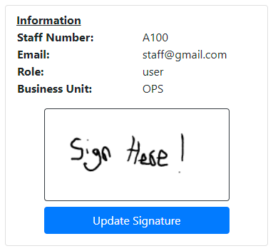

#### Signature Pad

You can sign in the inner white box of the window prompted after clicking the pad. Once the signature is confirmed, click **Save** to continue or **Clear** to reset the signature.

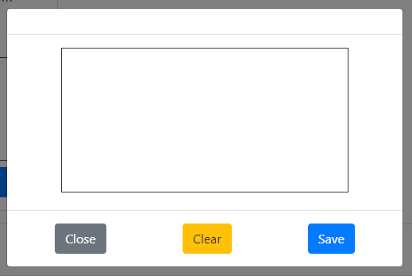

#### My Reports List

Clicking the report highlighted in blue open up to view the submitted report form.

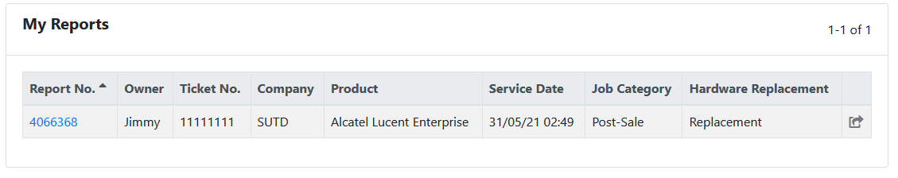

You can choose the following actions:

* **View the report** – Clicking the report number to view the report
* **Forward Report** – Clicking the forward icon will prompt a window. Inputting the email address allow user to forward an email copy to the target recipient.

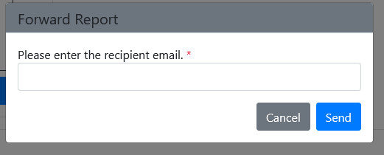

#### + Report

Directed to a report form. The button is usually found at the bottom of **My Reports**, **Template** or **All Reports** **(Manager Only)**. You can fill in the service report detail here.

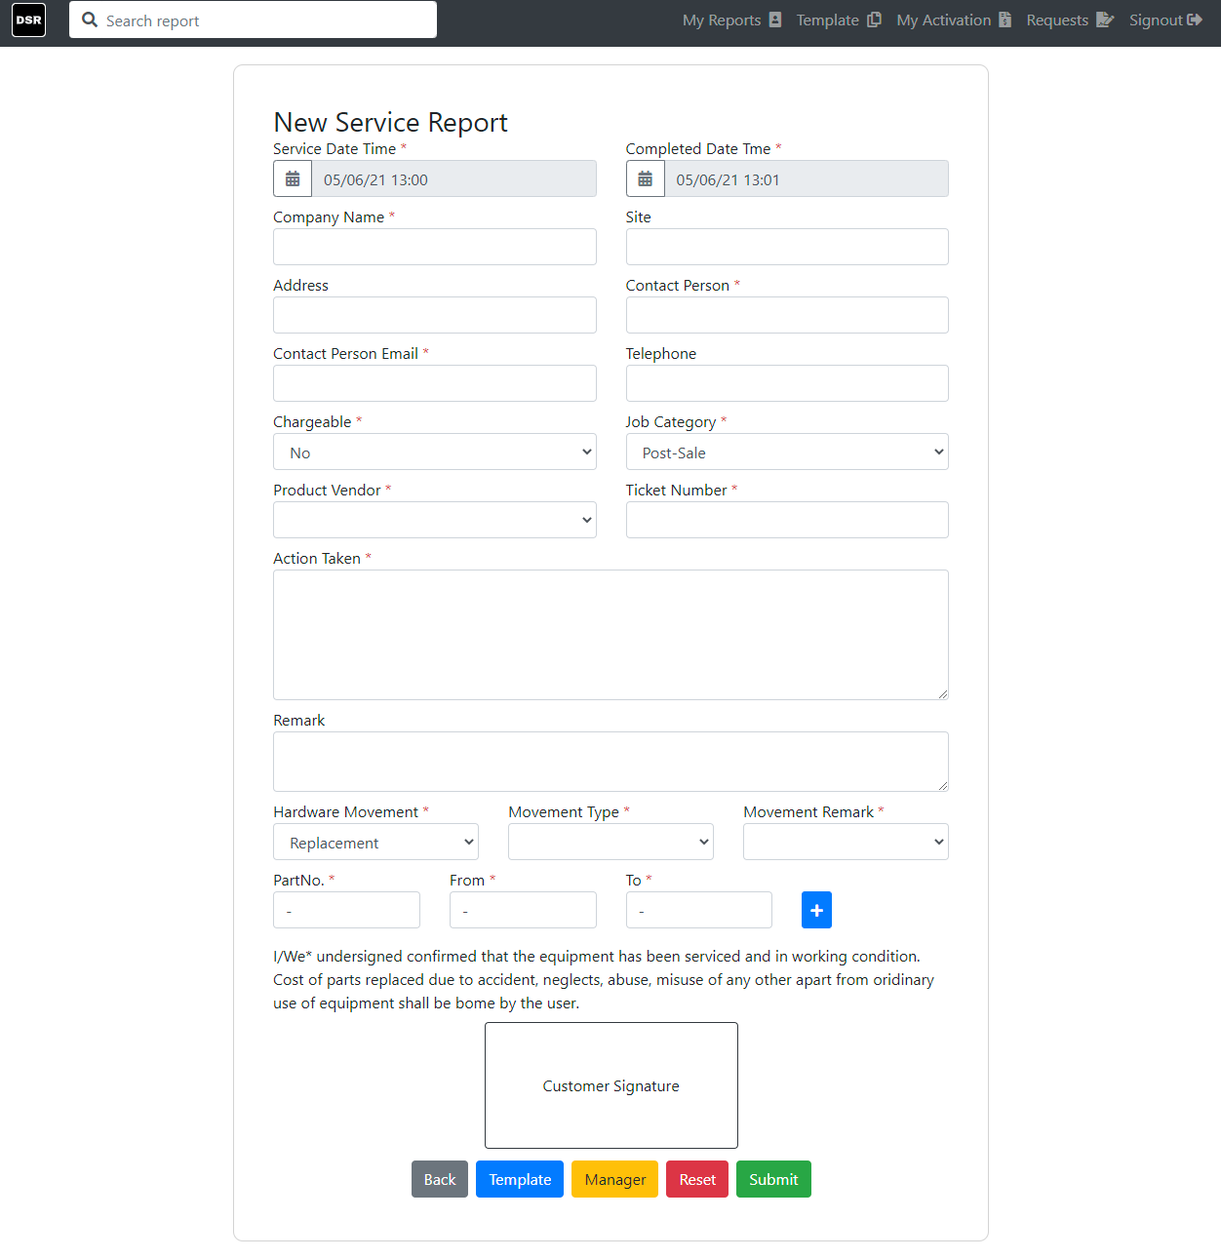

|  |  |
| --- | --- |
| **Parameter** | **Description** |
| Service Date Time | The date and time of the start of the service |
| Completed Date Time | The complete data and time of the service provided |
| Company Name | Customer company name the service is offered to |
| Site | Indication of building number or area if any |
| Address | The location of where the building is located at |
| Contact Person | The service requestor name |
| Contact Person Email | The service requestor name email address |
| Telephone | Mobile number of the service requestor |
| Chargeable | Indicate the service is free of charge |
| Job Category | Select the category of the job type. The options are:   * Post-Sale * Pre-sale * Project |
| Product Vendor | The product brand the service is provided for |
| Ticket Number | The issue ticket number that is related to the service issue |
| Action Taken | Information about what was done during the service |
| Remark | Additional point to take notice |
| Hardware Movement | Indicate when there is equipment movement made in the service, the options are:   * N/A * Replacement * Repair * Loan |
| Movement Type | Indicate the type of equipment movement, the options are:   * 3-Legged RMA * Maintenance Swap * Direct RMA |
| Movement Remark | Indication if the swap is permanent. Options are:   * Permanent Replacement * Temporary Loan |
| PartNo. | The part number of the equipment that has been equipment swapped |
| From | The original serial number of the before the equipment swapped |
| To | The new serial number after the equipment swapped |
| Customer Signature | Signature of the contact person to acknowledged the service has been delivered |

You can choose the following actions:

* **Template** – The report will be saved as template. This will generate another new template if it is select from a template form.
* **Manager** – Send the report to your direct superior for acknowledgement. Manager will receive an email notification about this request
* **Reset** – Reset the form
* **Submit** – Generate the report, an email copy of the report will be sent to the customer, user and manager

### Template

Display all the template that can be easily used to generate a report.

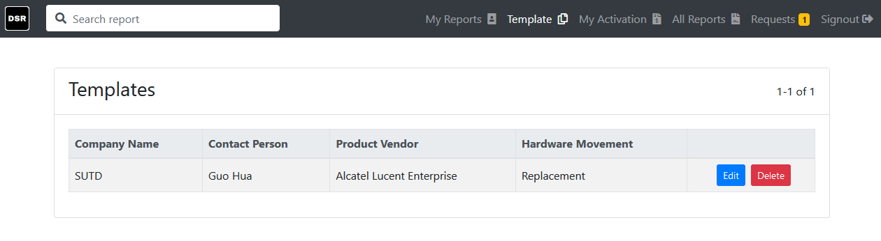

You can choose the following actions:

* **Edit** – Click to use the template report. The report structure is the same as a normal report service form.
* **Delete** – Delete the template report
* **+ Report** – Click this button to start drafting the report (Refer to **+ Report**)

### My Activation

Page to compile the monthly activation claim submission based on the services provided. The feature is not yet available on 0.1 build.

### All Reports (Manager Only)

Show all historical report generated by all users. Clicking the report allowing user to view the report in details.

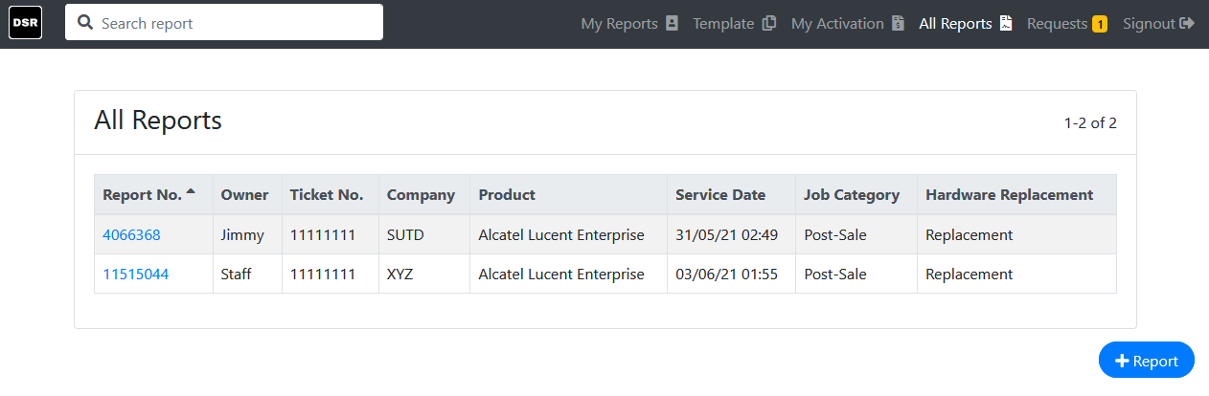

You can choose the following actions:

* **View the report** – Clicking the report number to view the report
* **+ Report** – Click this button to start drafting the report (Refer to **+ Report**)

### Requests

Display service report that has send to superior for acknowledgement but yet to be approved or rejected. For manager, they can view the signing request from this page as well. The number show by the name is the number of requests waiting for approval.

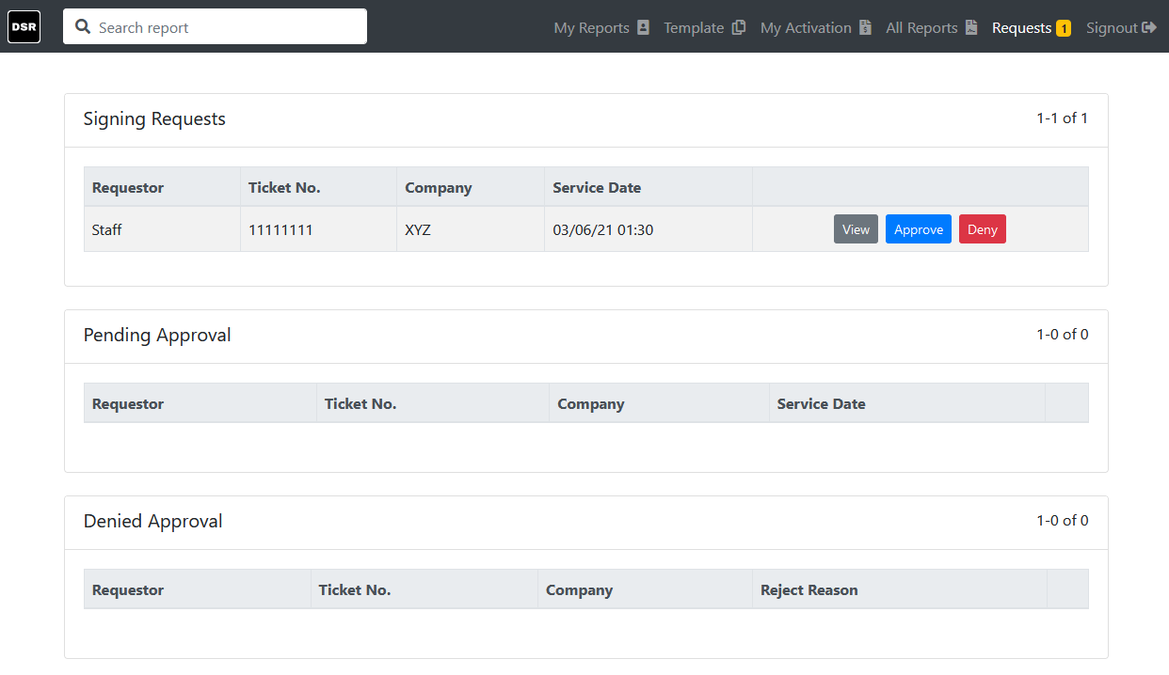

The request page consists of the following elements:

* **Signing Request (Manager Only)** – Display a list of service reports pending for signing acknowledgement.
* **Pending Approval** – Display a list of service reports that is waiting for superior to approval the service report before submission
* **Denied Approval** – Display a list of service reports that is rejected by the superior. Rejected reason is show here.

#### Signing Request (Manager Only)

Display the signing request by the subordinate to acknowledge their onsite services.

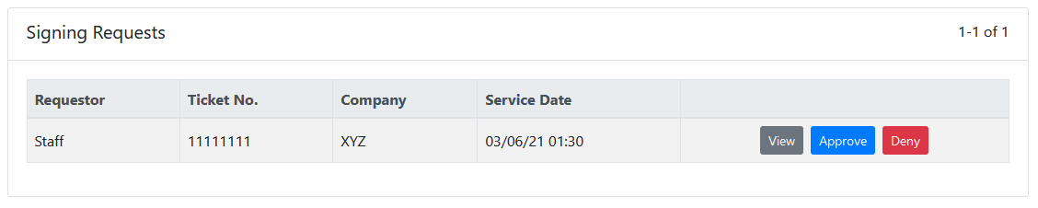

You can choose the following action:

* **View** – View the service report in details
* **Approve** – The report will be automatically sign by the manager and complete the submission.
* **Deny** – To reject the service report if deem inappropriate. This will prompt a window allowing manager to state the result of rejection.

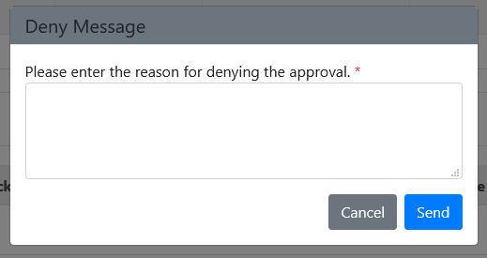

#### Pending Approval

List the service reports that are pending for superior to acknowledge.

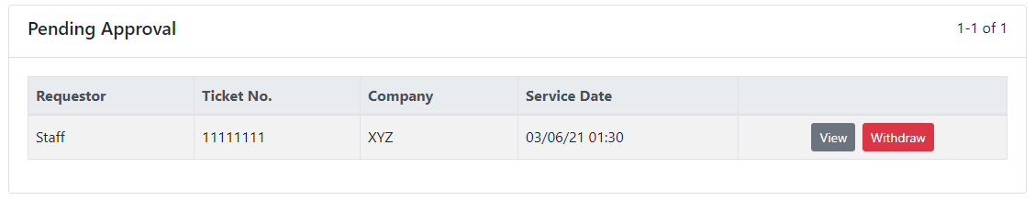

You can choose the following action:

* **View** – View the service report in details
* **Withdraw** – Drop the signing request.

#### Denied Approval

List the service reports that are pending for superior to acknowledge.

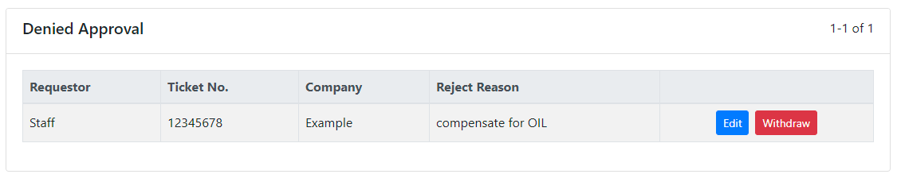

You can choose the following action:

* **Edit** – User can edit their report and re send it back to their superior for acknowledgement.
* **Withdraw** – Drop the signing request.